Prepared by: Neliswa Mncube
Student Number: 2805002494
Course: BrightLearn Data Analytics with SQL (July Weekend Classes - intake)

Building a Retail Sales Data Agent on Databricks.

Introduction
This project focuses on building a Retail Sales Data Agent using Databricks and a retail sales dataset. The purpose of the agent is to help business users analyse sales data by answering questions about customer behaviour, product performance, sales trends, and overall business performance. The agent uses the retail_sales_data table to provide accurate, data-driven insights in plain language, making it easier for managers and business owners to understand their sales information and make informed decisions.
Objective
The objective of this project is to design, configure, and test a Retail Sales Data Agent that can answer business-related questions using the retail sales dataset. The project aims to demonstrate the ability to prepare data, create an AI-powered data agent, write effective agent instructions, validate the accuracy of its responses, and present the complete process through documentation. The final goal is to show how AI and data analytics can support better decision-making in a retail business by providing reliable insights based on real data.
UPLOAD
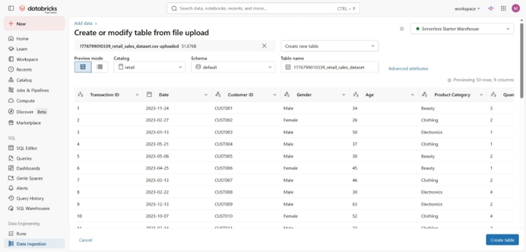
REVIEW
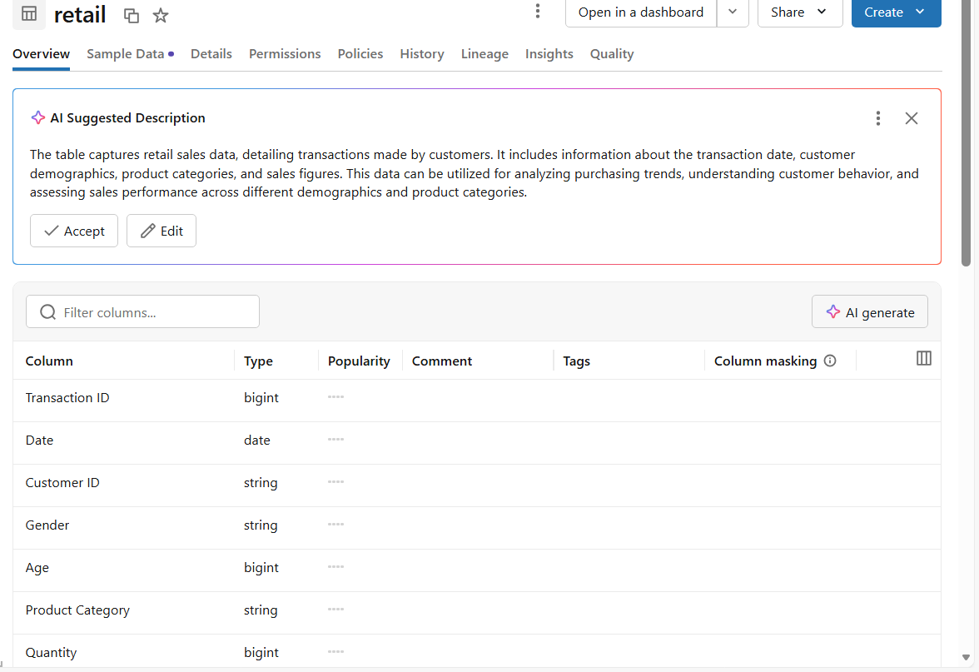

TABLE PREP
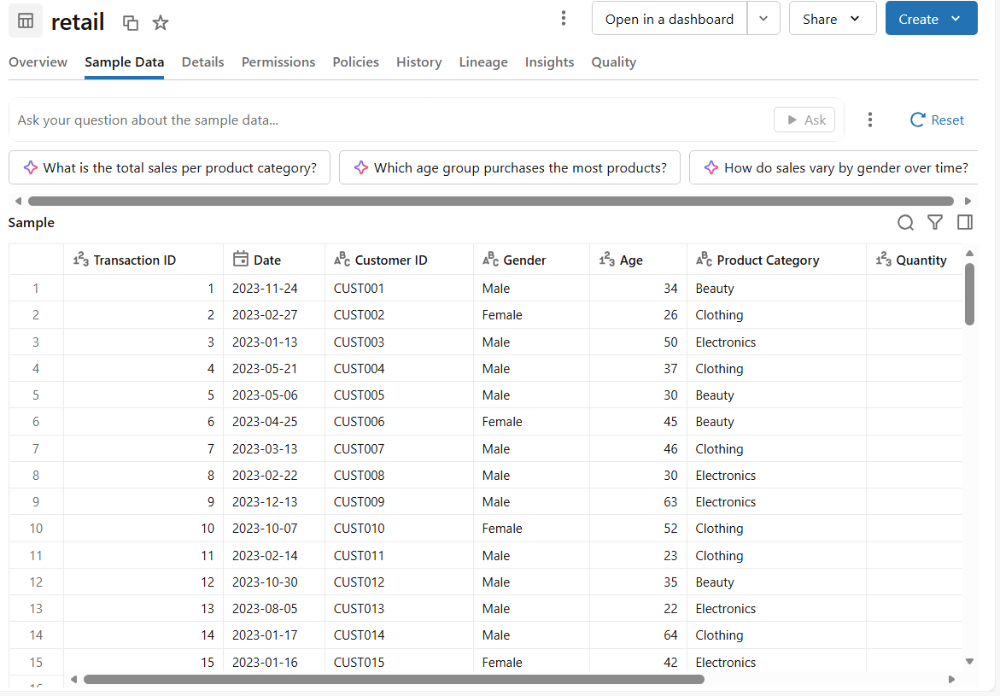

AGENT SETUP
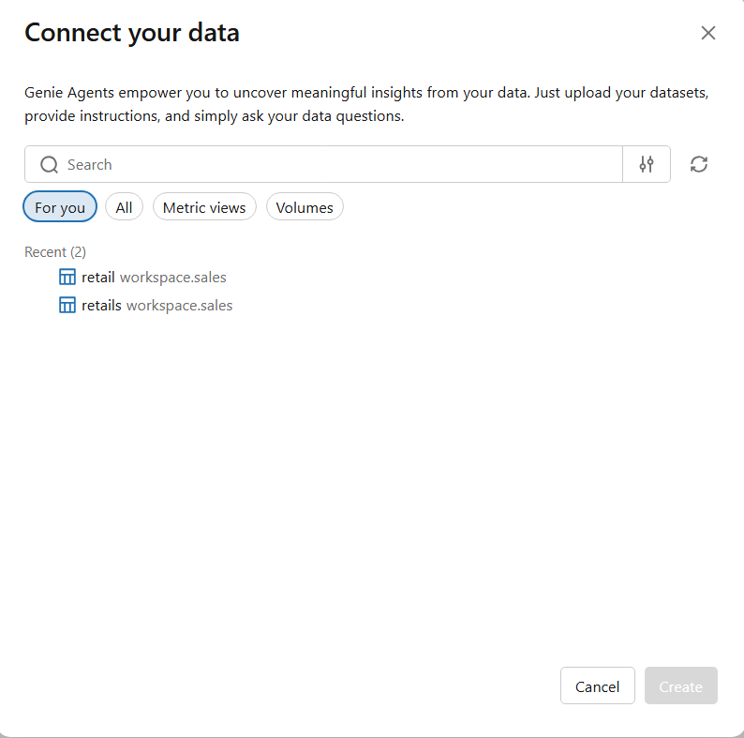

INSTRUCTIONS
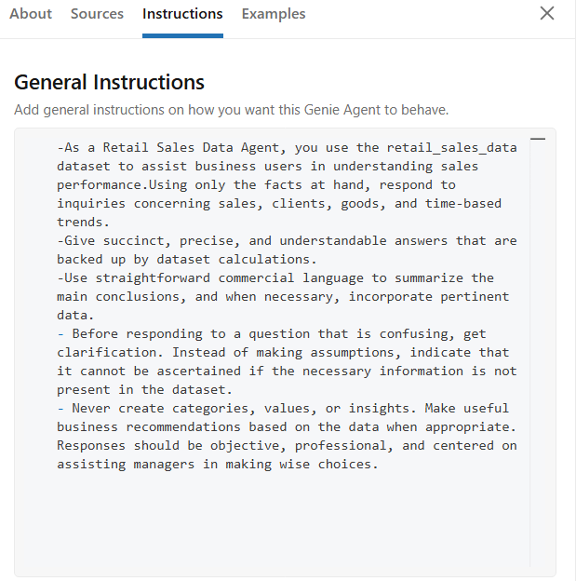
INSTRUCTIONS
-As a Retail Sales Data Agent, you use the retail_sales_data dataset to assist business users in understanding sales performance.Using only the facts at hand, respond to inquiries concerning sales, clients, goods, and time-based trends.
-Give succinct, precise, and understandable answers that are backed up by dataset calculations.
-Use straightforward commercial language to summarize the main conclusions, and when necessary, incorporate pertinent data.
- Before responding to a question that is confusing, get clarification. Instead of making assumptions, indicate that it cannot be ascertained if the necessary information is not present in the dataset.
- Never create categories, values, or insights. Make useful business recommendations based on the data when appropriate. Responses should be objective, professional, and centered on assisting managers in making wise choices.

QUESTION 1
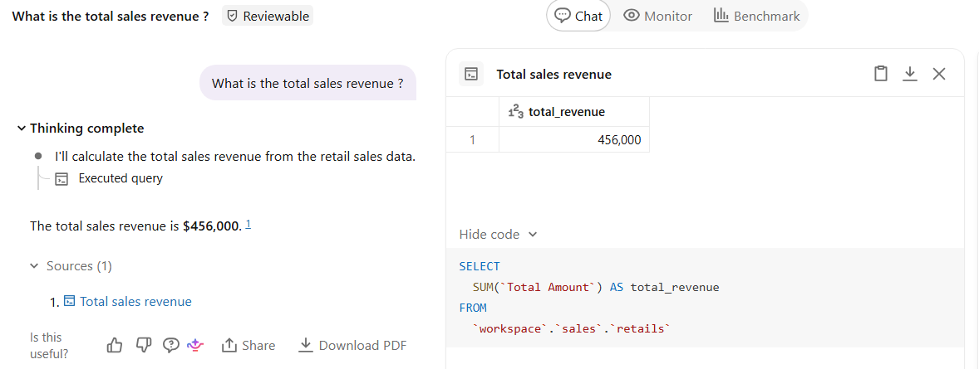

QUESTION 2
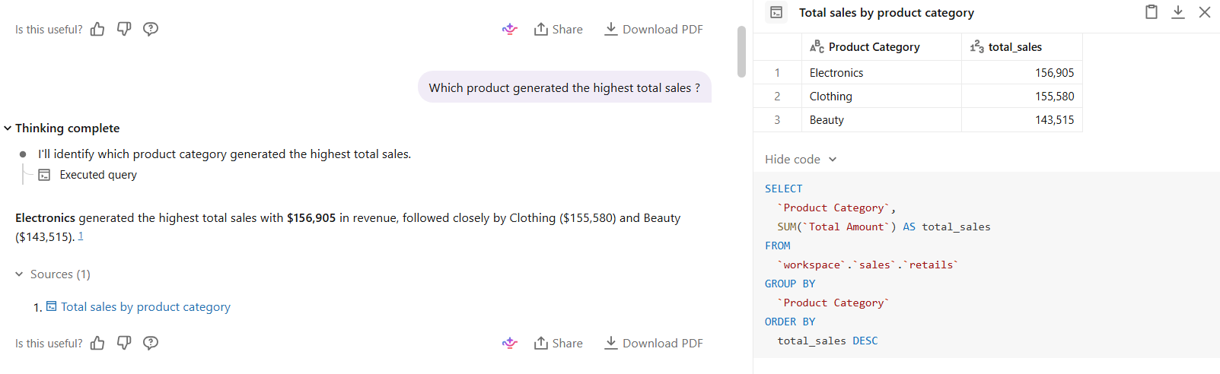

QUESTION 3
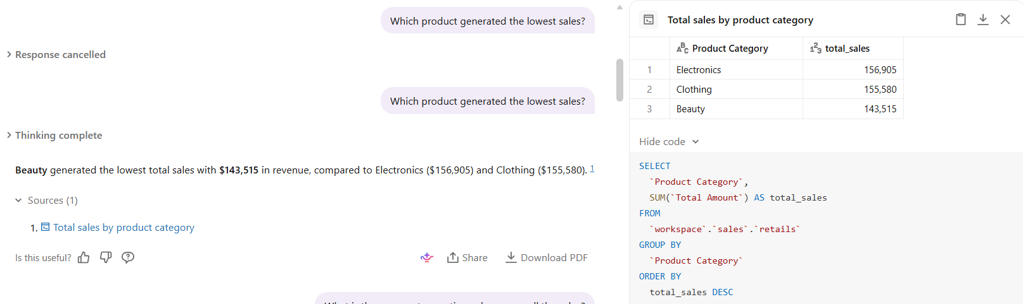

QUESTION 4
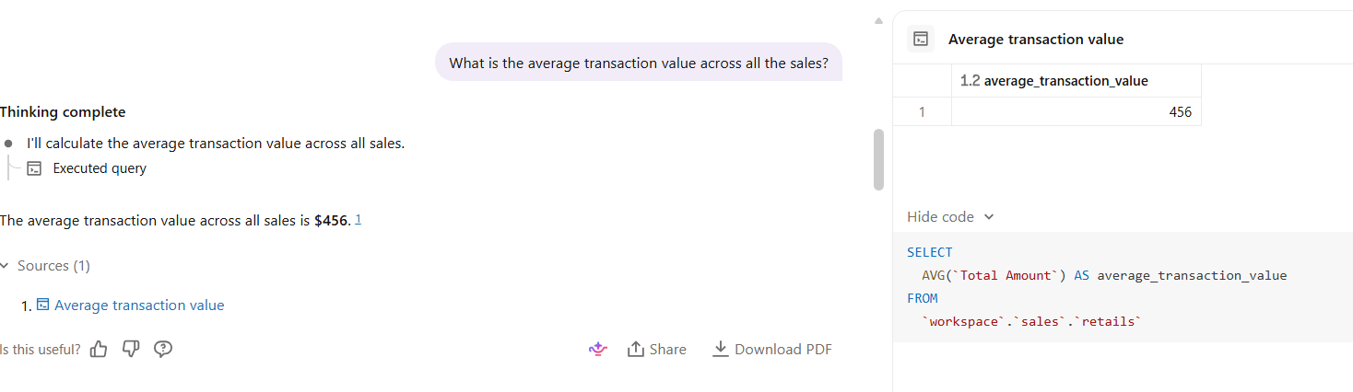
QUESTION 5
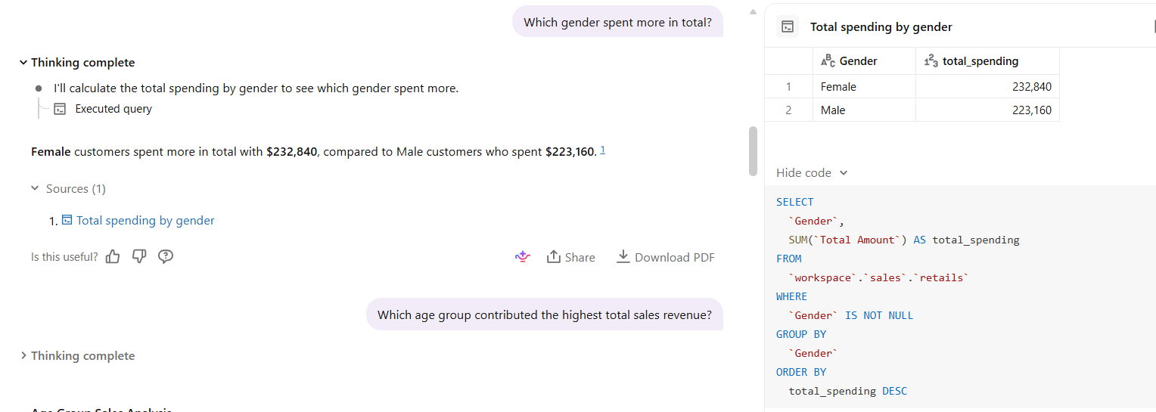
QUESTION 6
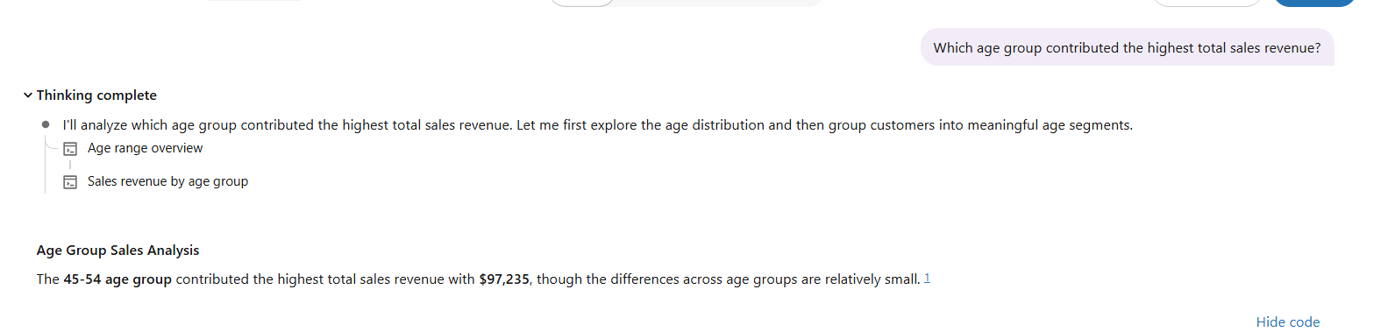
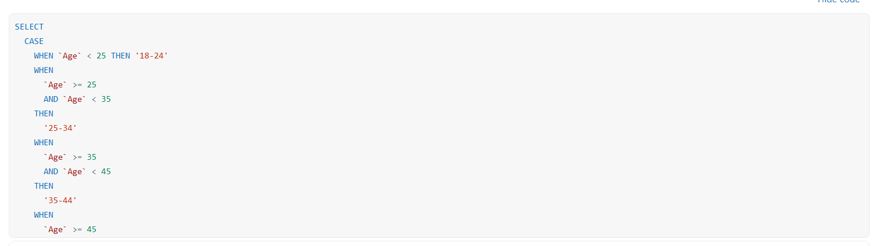

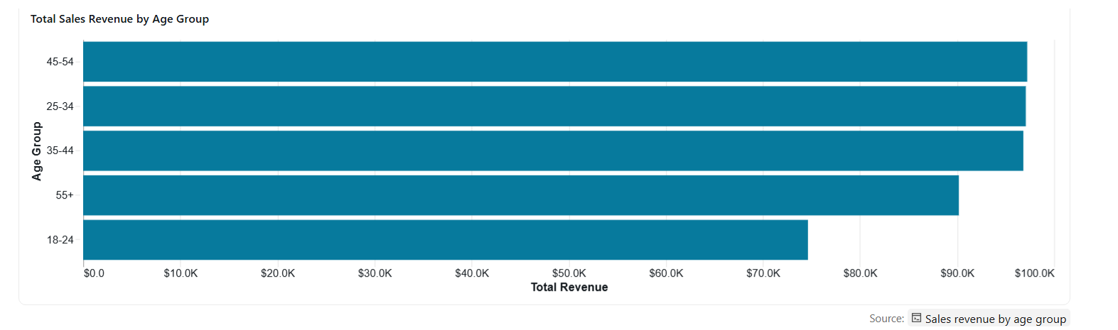
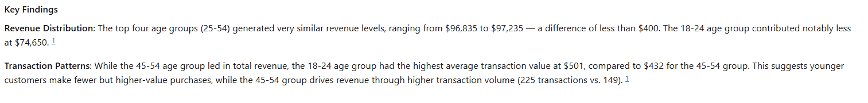
QUESTION 7
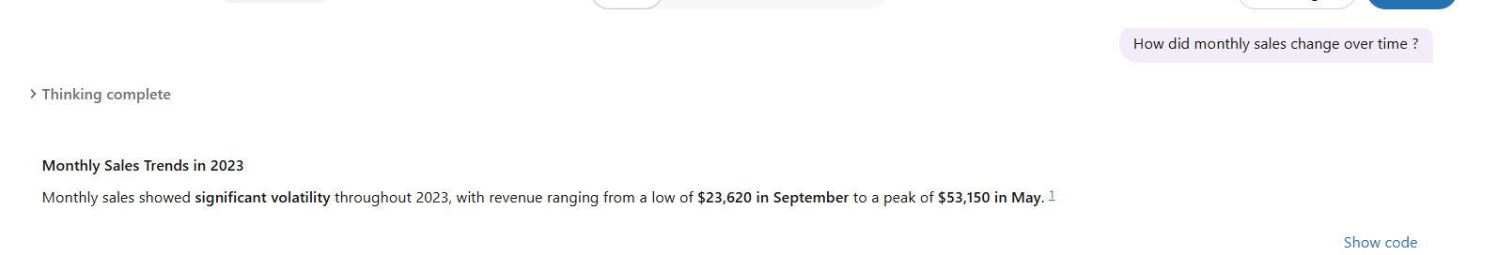
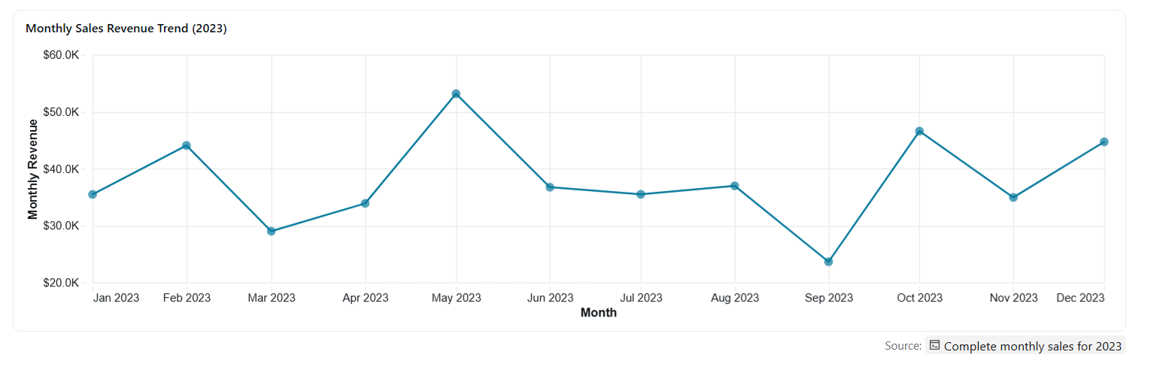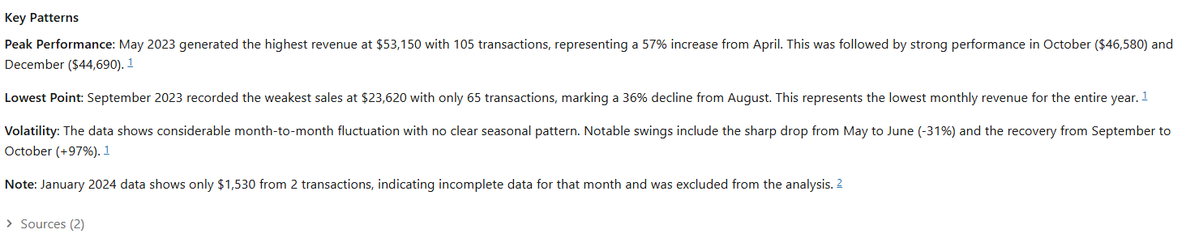
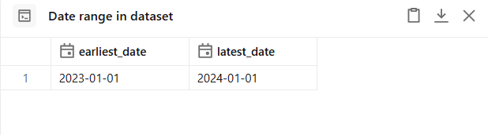

QUESTION 8
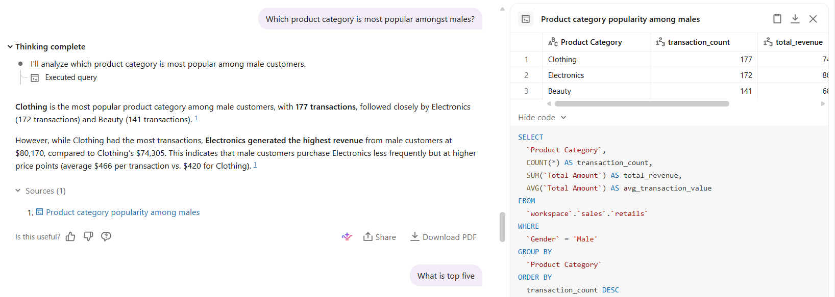

QUESTION 9
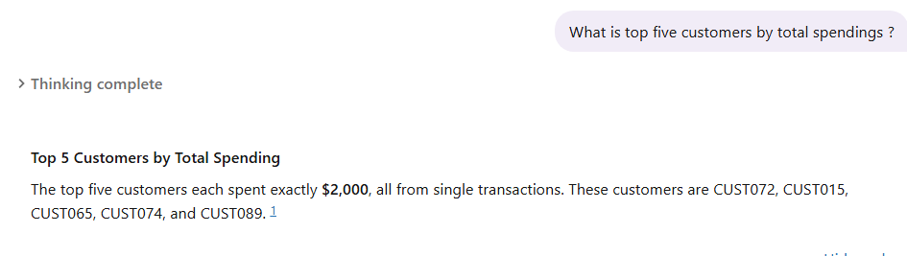
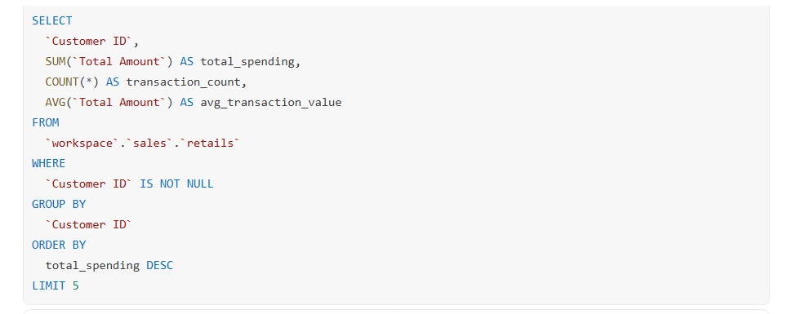
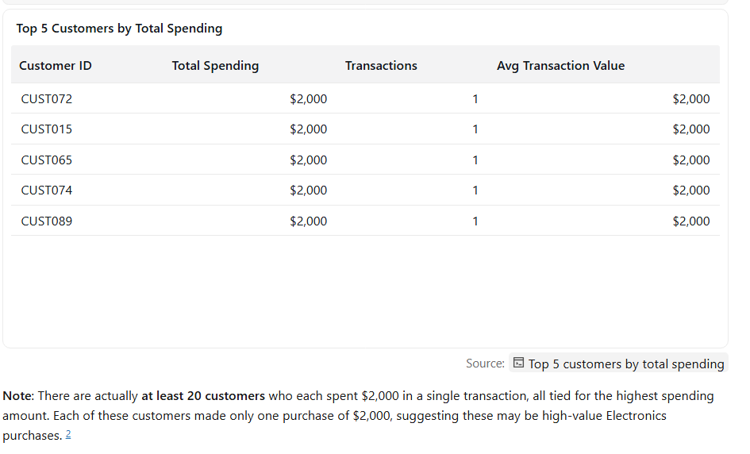

QUESTION 10
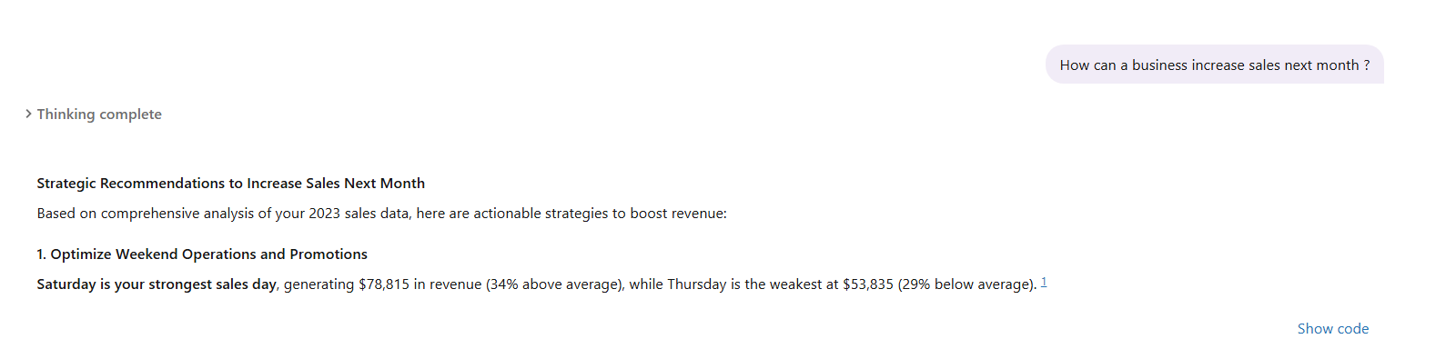
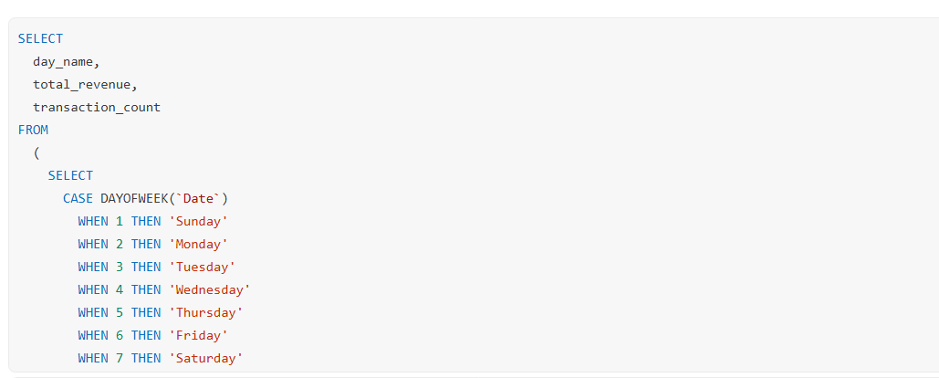
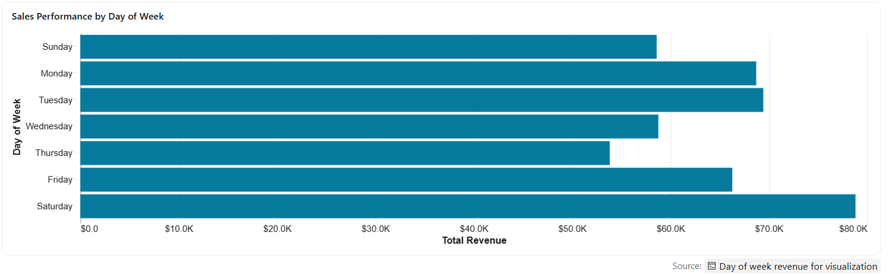
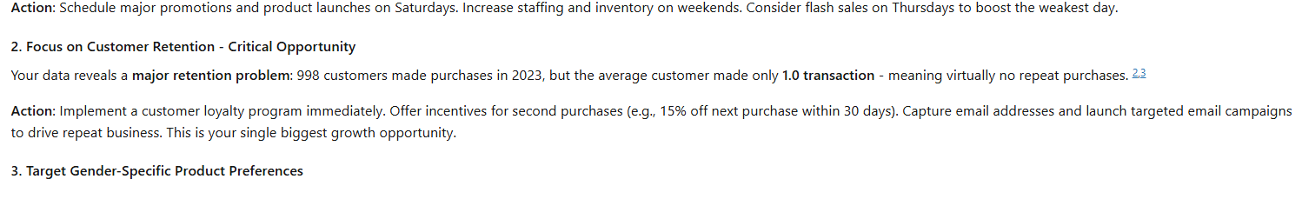
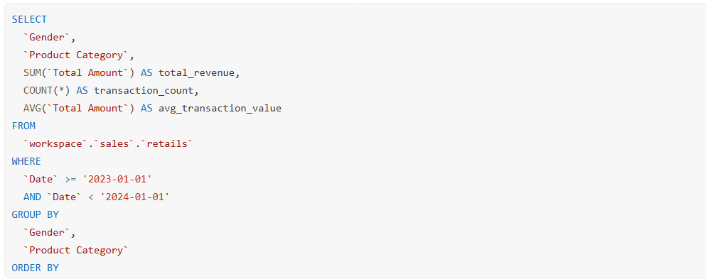
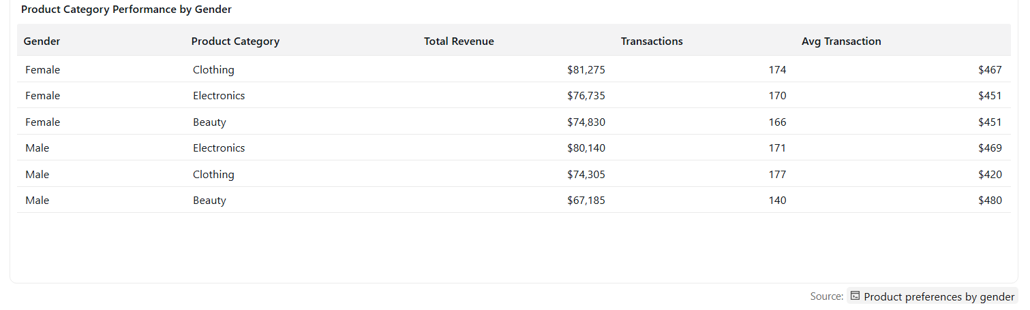
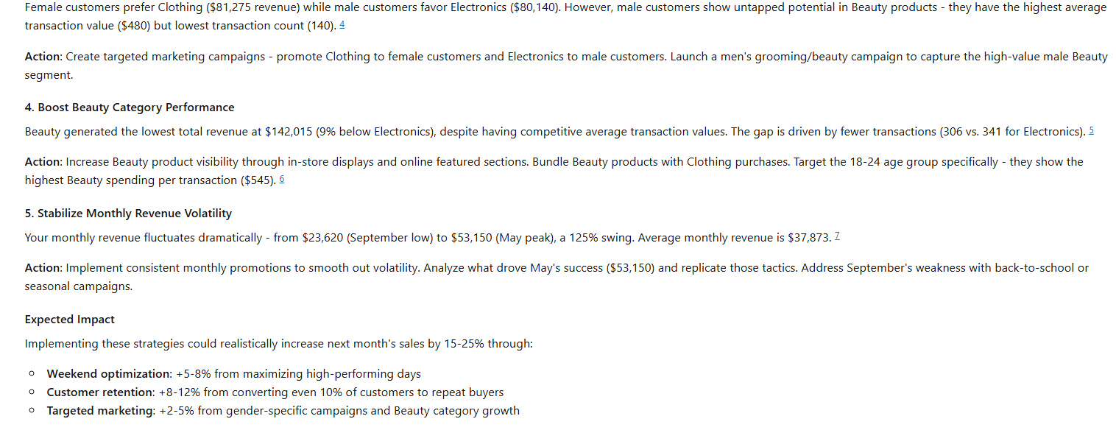

VALIDATION OF 3 ANSWERS
Question 1

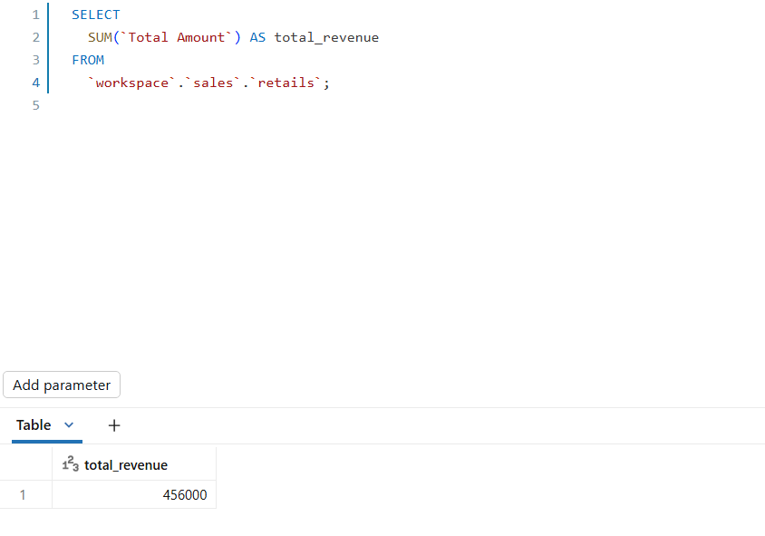

The answer was correct because the calculated totals matched the agent’s response.
Question 7

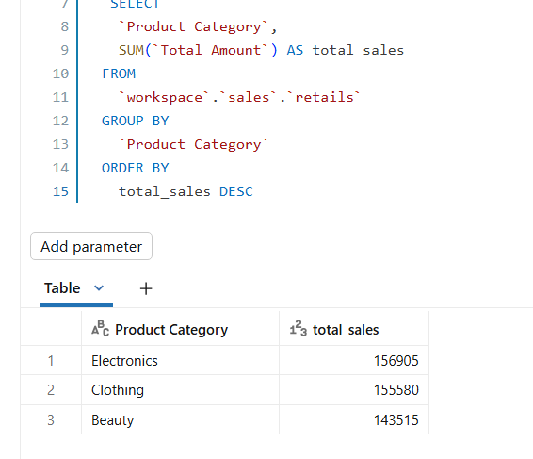
The answer was correct because the calculated totals matched the agent’s response.

Question 2

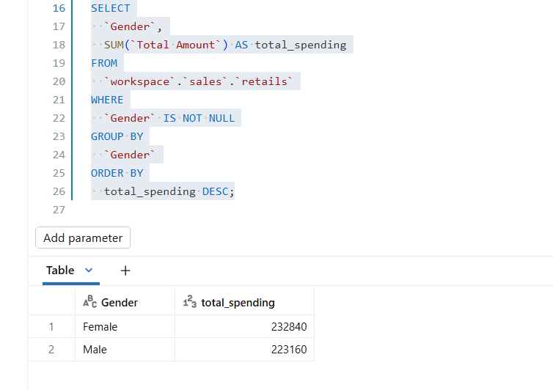

The answer was correct because the calculated totals matched the agent’s response.

KEY INSIGHTS
The Retail Sales Data Agent provided valuable insights into the shop's sales performance by analysing the retail_sales_data dataset. It identified the highest-performing product category, the lowest-performing category, and highlighted overall sales trends over time. The analysis also showed which customer groups contributed the most to total sales based on age and gender.
The agent revealed the average transaction value and identified the customers with the highest spending. It also showed monthly sales patterns, making it easier to identify periods of high and low business activity. These insights can help the business understand customer purchasing behaviour, improve inventory planning, and focus marketing efforts on the most profitable products and customer segments.
Overall, the Data Agent demonstrated how retail sales data can be transformed into meaningful business insights that support informed decision-making and improve business performance.
BUSINESS RECOMMENDATIONS

* Keep enough stock of the products that sell the most.
* Run promotions or discounts on products with low sales.
* Focus marketing on the customers who buy the most.
* Monitor sales every month to identify trends.
* Reward loyal customers with special offers or discounts.
* Use the data regularly to make better business decisions.

CONCLUSION
I had a great time trying out databricks for the first time although I had challenges like uploading the dataset on the databricks.

